Table of Contents
Table of Contents 2
Key 2
Introduction 2
Domain Properties 4
Domain Name & TLD 4
Domain Age & Ownership 5
SSL certificate & HTTPS/HTTP Issues 5
Preferred Domain & Trailing Slashes 6
301 redirects & 404 errors 8
301 Redirects 8
404 Errors 10
Functioning 404 Page 11
Google Properties 13
Analytics 13
Search Console 15
Google Algorithm 15
Google Data Analysis 16
Total Users 17
New Users vs Returning Users 18
Users by Country 19
User Source Type 20
Mobile vs Desktop 22
Site Speed 24
Bounce Rate 25
Time Spent per Session 27
Total Impressions vs Total Clicks 28
Average Click Through Rate (CTR) vs Average Position 30
Recommendations 30
Technical SEO 30
Low Value Pages, Indexing, & Robots.txt 31
XML Sitemap 33
Duplicate Content & Canonicalisation 34
Structured Data & Rich Results 35
Mobile Friendliness 36
Speed Test & Performance 38
Security Check & Malware Scan 41
Website Structure & Depth 42
Content Management System 43
General CMS 43
Yoast 44
Plugins 45
Summary and Conclusion 46
Areas for Improvement 46
Domain 47
301 Redirects & 404 Errors 47
Google 47
Technical SEO 48
CMS (WordPress) 48
Appendix: References and resources 49

Key

Green - Done well / trivial room for improvement
Orange - Done poorly / room for improvements
Red - Current state is detrimental to overall SEO / completely unimplemented
Blue - Our recommendation

Introduction
SEO services can play a crucial role in building visibility, brand awareness, traffic, and sales from organic search. We take an active step in understanding your business, its branding and positioning. There are over 200 ranking factors to Google’s algorithm.

Our approach focuses on targeting those factors that have the most influence, and those that will have the biggest return on investment.

A complete SEO Audit consists of three components:
- Technical / sitewide problems
- Content / on-page / page-specific problems
- Off-page / competitor problems.

This Technical Audit will deal with aspects relating to:
- The Domain (such as domain resolve problems or a lack of SSL),
- Your relationship with Google (ie. Google Analytics being set up poorly or Google My Business lacking details),
- Various Technical SEO properties (ie. slow site speed or a broken XML sitemap), and
- Wordpress specific characteristics (such as missing or outdated plugins).

We use premium tools and a methodological approach to consider a broad spectrum of metrics. We will provide you with a snapshot of the health of your website, pinpoint any problems, and suggest remedies to these problems.

This report can be used as either a basis for a retainer, or as a blueprint for your internal development team to resolve any technical issues to grow your site’s traffic.

Domain Properties

DOMAINl
lPROPERTIESl

Your domain is an important aspect of your website. It can help with brand recognition and indicate if you are country-specific. Mistakes in domain resolve and SSL can have strongly negative impacts on the SEO of your site.

Domain Name & TLD
Domain names are an important part of a successful website. In a domain you have 3 choices, each with their own pros and cons:

- Exact match domains eg websitedesign.co.za (EMD)
- Partial match domains eg: wowwdesign.co.za (PMD)
- Branded domains eg: woww.co.za (BD)
- TLD (Top Level Domain eg: .com / .co.za / .org)

 | TLD (top-level domain)  A TLD identifies something about the website associated with it, such as its purpose, the organization that owns it or the geographical area where it originates.
Generally your domain name and TLD will not be a problem. However, there are some cases where they can cause issues. For example, if you are targeting multiple markets internationally then you should have a generic (e.g. “.com”) TLD instead of a local (e.g. “.co.za”) TLD.

FINDINGS: https://pggames.com/

- N/A
- You have a soft- branded domain
- You have an international generic TLD (.com), which is appropriate for the brand and market.
- Domain might conflict with other terms like PG Games (Parental guidance) or other PG terms like Procter and Gamble.

RECOMMENDATIONS
- Consider migrating to paradisegames.com for an exact match domain, and having pggames.com redirect.

Domain Age & Ownership
This measures your domain’s age and owner information. Having ownership details that match your site’s content is preferable and an older domain is easier to rank.

Older domains tend to acquire backlinks over the years and get crawled by lots of systems. They are also considered to be more trustworthy as they have been around longer and have proven themselves as a reputable domain, unlike a fresh domain which could have been created with the intent of generating spam.

FINDINGS

- Your domain was registered on June 4, 2015. See here for more details.
- N/A
- N/A

RECOMMENDATIONS
- None.

SSL certificate & HTTPS/HTTP Issues
One of the most important components of online business is creating a trusted environment where potential customers feel confident in making purchases, sending enquiries or simply navigating your website.

SSL certificates create a foundation of trust by establishing a secure connection. To assure visitors their connection is secure, browsers provide visual cues, such as a lock icon or a green bar. Google has indicated that it rewards SSL sites over non-SSL sites.

 | SSL  Stands for "Secure Sockets Layer." SSL is a secure protocol developed for sending information securely over the Internet. Only the user's computer and the secure server are able to recognize the data.

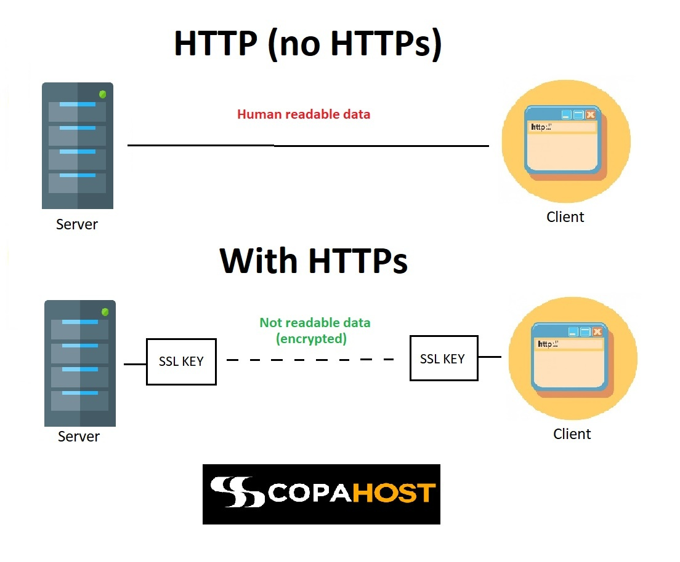

Source: Copahost

DATA COLLECTION

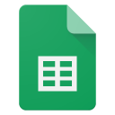 | Internal links to HTTP

FINDINGS

- Your site has an active and correctly configured SSL certificate.
- Both HTTP domain variants redirect to HTTPS equivalents.
  - HTTP versions of the root and www domains return 301 redirects to HTTPS.
  - No indexable HTTP pages were found.

RECOMMENDATIONS
- Keep the current HTTP-to-HTTPS 301 redirects in place and monitor them after future releases.
  - Continue consolidating signals to the HTTPS versions so users and search engines do not encounter insecure duplicates.
- Periodically recrawl internal links to confirm no new HTTP links are introduced.

Preferred Domain & Trailing Slashes
Preferred domain refers to whether your domain has only 1 active variation. This means that you choose 1 variation of your domain and then redirect the other 3 variations to this preferred variation.

If you have multiple versions of your domain then you will not rank as well as you could (because Google will consider your content to be duplicate content, thus diluting your ability to rank).

Example:
The “root with SSL” domain was chosen to be the preferred domain for Woww, and thus all other domain variations are redirected to the preferred domain.

- “http://woww.co.za/” (This is called the root domain)
- “http://www.woww.co.za/” (This is the www domain)
- “https://www.woww.co.za/” (This is the www with SSL)
- “https://woww.co.za/” (This is the root with SSL)

Trailing slashes refers to whether your URLs end with a “/” or not, and whether you are consistent in your approach regarding trailing slashes.

Poorly implemented trailing slashes can be extremely damaging because Google views (e.g.) https://woww.co.za/about/ and https://woww.co.za/about as different pages, and so you can slip down the search results for duplicate content if you have both versions of a URL on your site.

DATA COLLECTION

 | URL crawl - Paradise Games

FINDINGS

- The site uses a mixed URL pattern across the root domain, www variant, and classic mobile subdomain.
- Both https://pggames.com/ and https://www.pggames.com/ resolve as 200 indexable pages. This creates duplicate homepage variants and leaves the preferred hostname unclear.
  - https://pggames.com/
  - https://www.pggames.com/
  - https://classic.pggames.com/Mobile/
  - https://pggames.com/footer
  - https://www.pggames.com/home/contactsupport
  - https://pggames.com/home/contactsupport
  - https://www.pggames.com/footer
- Non-secure domain variations redirect to HTTPS, but the preferred canonical hostname should be clarified because both root and www HTTPS variants resolve.
- N/A

RECOMMENDATIONS
- Keep the current HTTP-to-HTTPS 301 redirects in place and monitor them after future releases.
  - Choose one preferred HTTPS hostname, then 301 redirect the alternate HTTPS hostname to it. This will consolidate duplicate homepage signals and make the preferred domain clearer to search engines.
- Review classic.pggames.com mobile URLs separately from the main site and confirm whether they should be indexed, canonicalised to the main experience, or kept as a distinct mobile journey.


301 redirects & 404 errors
l301 REDIRECTS &l
l404 ERRORSl
For most sites, 301 redirects and 404 errors won’t be a huge issue. However, if you have a large number of them or some systemic problem which generates them, then they can become a significant issue.

301 Redirects
301 redirects cause a user (or search engine crawler) to be redirected from a URL to another URL. They can be useful, e.g. by redirecting users from http versions of your site to https (i.e. secure) versions of your site. However, 301 redirects can also harm the ability of your site to rank on Google, because they can worsen performance and are used in spam tactics .

One way in which a 301 redirect can harm your site is if the redirect is unnecessary. For example: your homepage internally links to an http page which is then redirected to the https page - you should just have linked directly to the https page (and avoided the unnecessary 301 redirect).

Another way in which 301 redirects can harm your site is redirect chains. For example: the “www” domain redirects to the “root” domain which redirects to the “root with SSL” domain - this redirect chain could be avoided by redirecting the www domain to the root with SSL domain directly.

We used Ahrefs to crawl your site. We then analysed the Ahrefs data with regard to 301 redirects and redirect loops.

DATA COLLECTION

 | 301 redirects - Paradise Games
 | Redirect Chains - Paradise Games
 | Pages with internal links to 301 redirects - Paradise Games

FINDINGS

- N/A
- There are 2 HTTP domain URLs that redirect with a 301 status code.
  - http://www.pggames.com/ redirects to https://www.pggames.com/.
  - http://pggames.com/ redirects to https://pggames.com/.
- There are internal links pointing to 302 redirect targets, mainly classic mobile URLs and SwitchUI endpoints. These are navigational and account journey links, not product/category archive issues.
  - Key 302 targets include https://classic.pggames.com/Mobile, https://classic.pggames.com/, and https://classic.pggames.com/Home/SwitchUI.
  - Several navigation links point to URLs that redirect before reaching the final mobile page.
    - The most common 302 targets are https://classic.pggames.com/Mobile, https://classic.pggames.com/, and https://classic.pggames.com/Home/SwitchUI.
    - The affected source pages include the homepage, classic mobile homepage, Results, SignUp, RecoverPin, and Terms pages.
    - The source anchors include Home, Mobile Site, Desktop Site, and click here.
    - These redirects are not multi-step chains, but they are still avoidable internal redirects.
  - 0 links to 301 redirects in the sitemap.
    - No redirected URLs were found in the sitemap.
    - No publicly accessible sitemap found.
  - The 302 URLs resolve in one hop, so there are no multi-step redirect chains.
    - https://classic.pggames.com/Mobile
    - No multi-step redirect chain identified.
- N/A

RECOMMENDATIONS
- Update internal links so they point directly to the final destination URLs rather than 302 redirect URLs.
- Prioritise navigation links and account journey links, especially sign-up, results, terms, and recover PIN paths.
- Where a classic mobile URL redirects to a trailing-slash version, update the source link to the final URL.
- Keep the HTTP-to-HTTPS redirects, but avoid linking internally to HTTP URLs.
- Review whether classic mobile pages should remain indexable or use canonical tags to clarify their relationship to the main experience.
- Document the preferred URL rules for the root, www, and classic mobile subdomain so future links stay consistent.

404 Errors
A 404 error occurs when a user or search engine crawler tries to access a page which does not exist on your site. This can result in a frustrating user experience and a diminished SEO rating by crawlers.

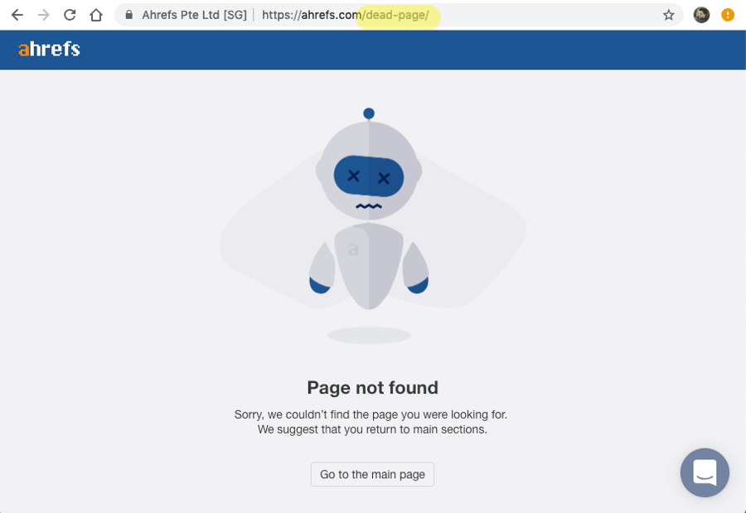

Internal links (links on your own site) to 404 errors should be fixed. External links (links on other people’s sites) to 404 errors should be redirected (using a 301 redirect) to an appropriate page (if there is a lot of traffic flowing through the link).

We used Ahrefs to crawl your site. We then analysed the Ahrefs data with regard to 404 errors.

DATA COLLECTION

 | 404 errors - Paradise Games
 | Pages with internal links to 404 errors - Paradise Games

FINDINGS

- N/A
- There are 2 404 URLs.
- One internal link points to a broken PDF path, and one promotional image asset is also broken.
  - The broken PDF target is https://classic.pggames.com/Mobile/~/Images/Gamingbill2014.pdf.
  - The source page is https://classic.pggames.com/Mobile/Terms, using anchor text “(click here)”.
    - The broken image asset is https://classic.pggames.com/Images/Modal/promo-image.jpg.
    - These are isolated broken asset/link issues rather than a sitewide 404 pattern.
  - 0 links to 404 errors in the sitemap.
    - No 404 URLs were found in the sitemap.
- N/A

RECOMMENDATIONS
- Fix the two 404 errors.
  - Update the Terms page link so it points to the live Gamingbill2014.pdf file path.
  - Restore or replace the missing promo-image.jpg asset so the mobile modal does not request a broken image.
    - After the fixes, recrawl the site to confirm both 404 URLs return a 200 or appropriate redirect.
    - Keep a small redirect map for any removed campaign or PDF assets so older links continue to resolve.
  - These 404 issues are caused by missing or incorrect asset/link paths rather than HTTPS enforcement.

Functioning 404 Page
A 404 page displays when a page cannot be found on a website. According to Google, it should have the following criteria:

- Tell visitors clearly that the page they’re looking for can’t be found
- Use language that is friendly and inviting
- Make sure your 404 page uses the same look and feel (including navigation) as the rest of your site.
- Consider adding links to your most popular articles or posts, as well as a link to your site’s home page.
- Think about providing a way for users to report a broken link.
- Make sure that your webserver returns an actual 404 HTTP status code when a missing page is requested
It is important for users to know whether a page exists or not when they either click on a non-existent page or make a spelling mistake in the URL. A 404 page is the perfect way to redirect users back to the homepage or to the page they may have been looking for.

Google also recognises if you have a 404 page, and ranks you better for it.

FINDINGS

- 404 Page functions, but it should be improved.
  - Tells visitors clearly that the page they’re looking for can’t be found
  - Use language that is friendly and inviting
  - Uses the same look and feel (including navigation) as the rest of your site.
  - Returns an actual 404 HTTP status code when a missing page is requested
- Users can navigate away using header/footer navigation, but the 404 page does not provide a clear primary Back to Home action.
- No way for users to report a broken link.
- No useful recovery links are included on the 404 page.
- N/A

RECOMMENDATIONS
- Add a clear “Back to Home” button so users can easily navigate back to the homepage.
- Add helpful navigation links such as popular pages, key product/service pages, or recent content to help users continue browsing the site.
- Include a broken link reporting option (e.g., contact form or email link) so users can notify the site owner of missing pages.

Google Properties

lGOOGLEl lPROPERTIESl
Google search is one of the primary ways in which people find websites. Managing your relationship with Google is essential if you want Google to rank your pages highly in search results.

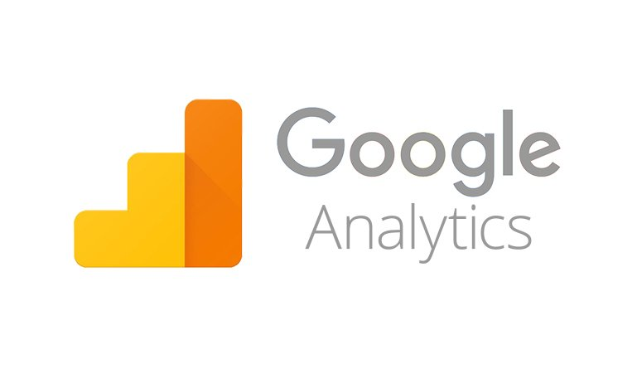
Analytics

Google Analytics is a free web analytics tool offered by Google to help you analyze your website traffic.

Given that your website is the central hub of your digital presence, your website is the best way to give you a holistic view of the effectiveness of all the campaigns you are running to promote your product/services online.

Google Analytics is a way to measure the site's traffic and gain insight into how users perform, where they are coming from and how they’re interacting with your site from both a holistic viewpoint all the way down to analysis of a single interaction.

FINDINGS

- Site has properly tracking Google Analytics Property:
  - GA4: G-42PZ2GBJLL
- The preferred URL is configured correctly.
- Your GSC is linked to your GA
- Your e-commerce and goals are set up.
- Your Google Ads is linked to your GA.
- Site Search, bot exclusion, & demographics have been enabled.
- N/A
- N/A

RECOMMENDATIONS
- N/A


Search Console
Search Console tools and reports help you measure your site's Search traffic and performance, fix issues and make your site shine in Google Search results.

FINDINGS

- 1 variation of the domain have been added and are verified:
  - https://pggames.com/
- No manual Google Penalties.
- No security issues (Malware / Hacks)
- All pages have poor LCP (longer than 4s)
  - LCP measures how long it takes for the main content to appear on screen. A slow LCP can frustrate users, making your website feel slow, which leads to lower rankings in Google’s Core Web Vitals assessment.
  - 36/95 pages have INP issue (longer than 200ms) (mobile only)
- There are some mobile usability issues.
  - 36 pages have an INP issue (longer than 200ms) (mobile only)
    - Interaction to Next Paint (INP) is a Core Web Vital that measures how quickly a website responds when a user interacts with it. For example, if JavaScript is still executing when a user clicks a button, the browser must wait before responding.
- There is no domain property + 3 other variants (https://www.pggames.com/, http://pggames.com/, and http://www.pggames.com/)
- N/A

RECOMMENDATIONS
- Improve INP
  - Reduce heavy JavaScript execution and remove unused scripts.
  - Defer or delay non-critical JavaScript until after page load or user interaction.
  - Limit third-party scripts that block the main thread.
  - Reduce long main-thread tasks by splitting large scripts into smaller tasks.
  - Simplify complex page layouts and reduce excessive DOM elements.
- Improve LCP
  - Reduce server response time through improved hosting or caching.
  - Optimise the largest image above the fold (compress and serve in WebP/AVIF format).
  - Preload the main hero image or the key assets above the fold.
  - Reduce render-blocking CSS and JavaScript.
  - Use a CDN to deliver static assets faster.

Google Algorithm
Google uses a machine-learning artificial intelligence system called “RankBrain” to help sort through its search results.This algorithm is periodically updated and sometimes has significant impact on search engine results.

FINDINGS

We’ve plotted your site’s traffic against some of the major updates for the last 2 years.
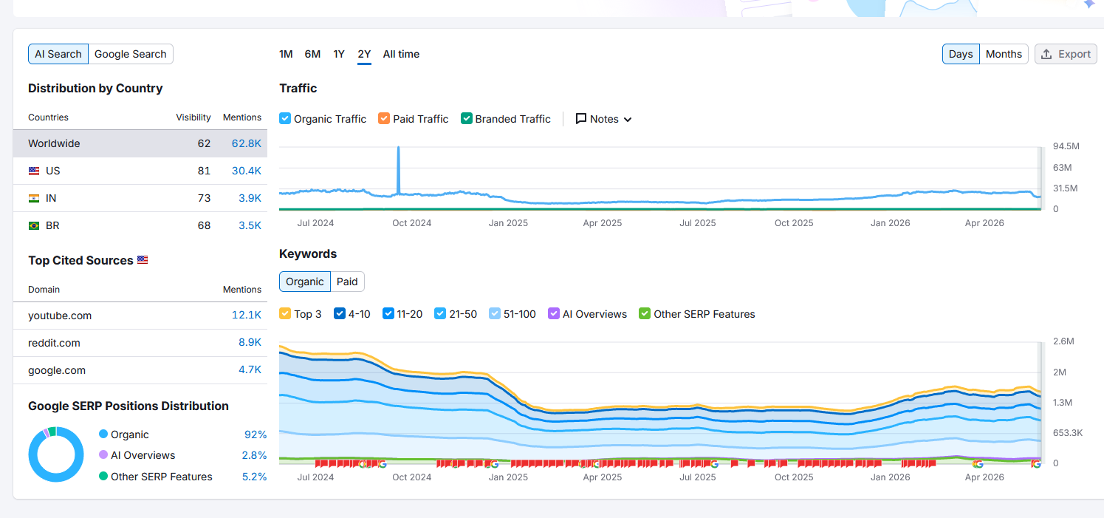
- No definitive impact from algorithm updates
- Potential impact from December 2024 Google Core & Spam Updates
  - However, there is not enough historical data to validate against in Google Search Console or Google Analytics.
  - Source: Search Engine Journal
- N/A

 | SERPs  Search Engine Results Pages (also known as “SERPs” or “SERP”) are Google's response to a user's search query. SERPs tend to include organic search results, paid Google Ads results, Featured Snippets, Knowledge Graphs and video results.

RECOMMENDATION
- None

Google Data Analysis
In this section we will analyse your Google Analytics data and your Google Search Console data.

The Google Analytics data goes back 2 years (24 months) and is monthly data, while the Google Search Console data goes back 16 months and is daily data (this is a limitation of Google Search Console).

DATA COLLECTION

Google Data Analysis - Paradise Games

FINDINGS

- n/a
- Google Analytics and Google Search Console were set up during the audit, meaning there is insufficient data to draw upon.
- Google Search Console data indicates the site received 22k clicks and 58k impressions from 14 to 18 May.
  - 15.5k clicks and 22.4k impressions are from queries containing “Paradise Games”
  - 17.9k clicks and 29.7k impressions are from queries containing “Paradise”.
- N/A

RECOMMENDATIONS
- Diversify traffic sources to reduce reliance on branded traffic by:
  - Creating dedicated pages for specific casino/online games.
  - Creating dedicated pages for betting on specific sports.
  - Leverage paid search and social media marketing if/where possible.

Total Users
This graph looks at the total raw number of users and returning users over time. This is one of the most basic metrics to consider: is your site becoming more popular? Often there are seasonal or annual cycles, which is why we look at 2 years (as looking at 1 year (or less) could lead to mistaking a cycle for a trend).

Screenshot not available - insufficient data

ANALYSIS
- N/A

New Users vs Returning Users
The graph below shows the percentage of all users who are returning users over time. This is important because a decline in returning users could indicate that your site has become worse or that your competitors have become better.

Screenshot not available - insufficient data

ANALYSIS
- N/A

Users by Country
This section looks at users by country. The map below is a screenshot from your Google Analytics dashboard - it can be found under Audience > Geo > Location. The map on Google Analytics is interactive and you can zoom into each country and see which province or region visits your website the most. This map is for the last 2 years of data.

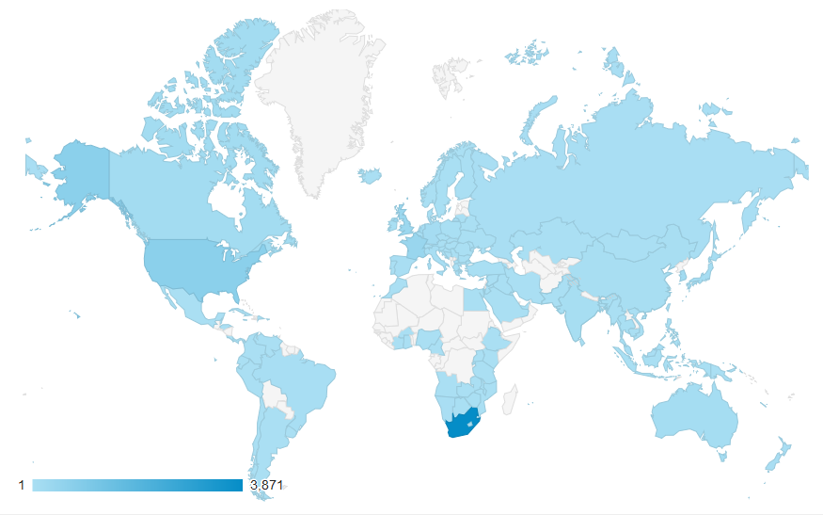

The bar chart below shows the top 10 countries by users. Note that the data labels won’t add up to 100% as a number of countries are excluded from the list.

Screenshot not available - insufficient data

ANALYSIS
- N/A

User Source Type
This section looks at the raw number of sessions from different source types: paid (paid search), organic (non-paid search, i.e. finding the website through unpaid google search results), direct (i.e. typing the website URL directly into the browser), and referral (referral links).

The graph below looks at the raw number sessions by user source type.

Screenshot not available - insufficient data

ANALYSIS
- N/A

The graph below shows the different source types as a percentage of total sessions. This is useful because looking at raw numbers alone will sometimes leave you without certain insights (especially e.g. if there is both a cycle and a trend in the data).

Mobile vs Desktop
This section shows your site’s traffic sources (looking at the raw number of sessions): desktop, mobile, and tablet. This is important because sites can work well on desktops and poorly on mobile, and so you want to know how much of your traffic is coming from mobile (and how it’s changing over time).

Screenshot not available - insufficient data

ANALYSIS
- N/A

Bounce Rate
The bounce rate refers to the percentage of users who navigate away after viewing a single page. The average bounce rate is 40-55% and anything above 60% may indicate a problem.

The graph below compares the bounce rate of desktop users and mobile users. This is important because mobile and desktop experience may differ substantially leading to some users wanting to look at more pages and others leaving.

Screenshot not available - insufficient data

ANALYSIS
- N/A

Time Spent per Session
The bar chart below compares desktop vs mobile time per session. It’s normal to have a fairly high percentage of sessions end in less than 10 seconds. This metric allows us to see just how engaged people are.

The bar chart below shows time per session comparing desktop and mobile.

Screenshot not available - insufficient data

ANALYSIS
- N/A

Total Impressions vs Total Clicks
This dataset comes from Google Search Console, and thus only goes back 16 months (as opposed to going back 2 years like the rest of the data presented so far).

The graph below shows total clicks on the left axis and total impressions on the right axis. Note that the axes are different.

Total clicks refers to the total number of times a user clicks on a link to your website in the search results. Total impressions refers to the number of times a user saw a link to your website in the search results (this takes into account whether the link was scrolled into view or not).

Global
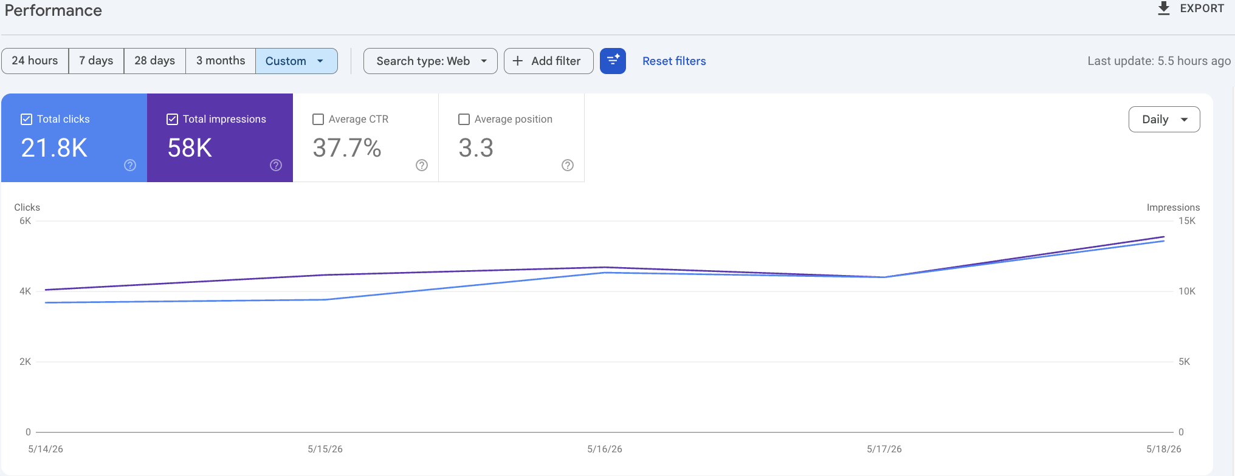

Bahamas
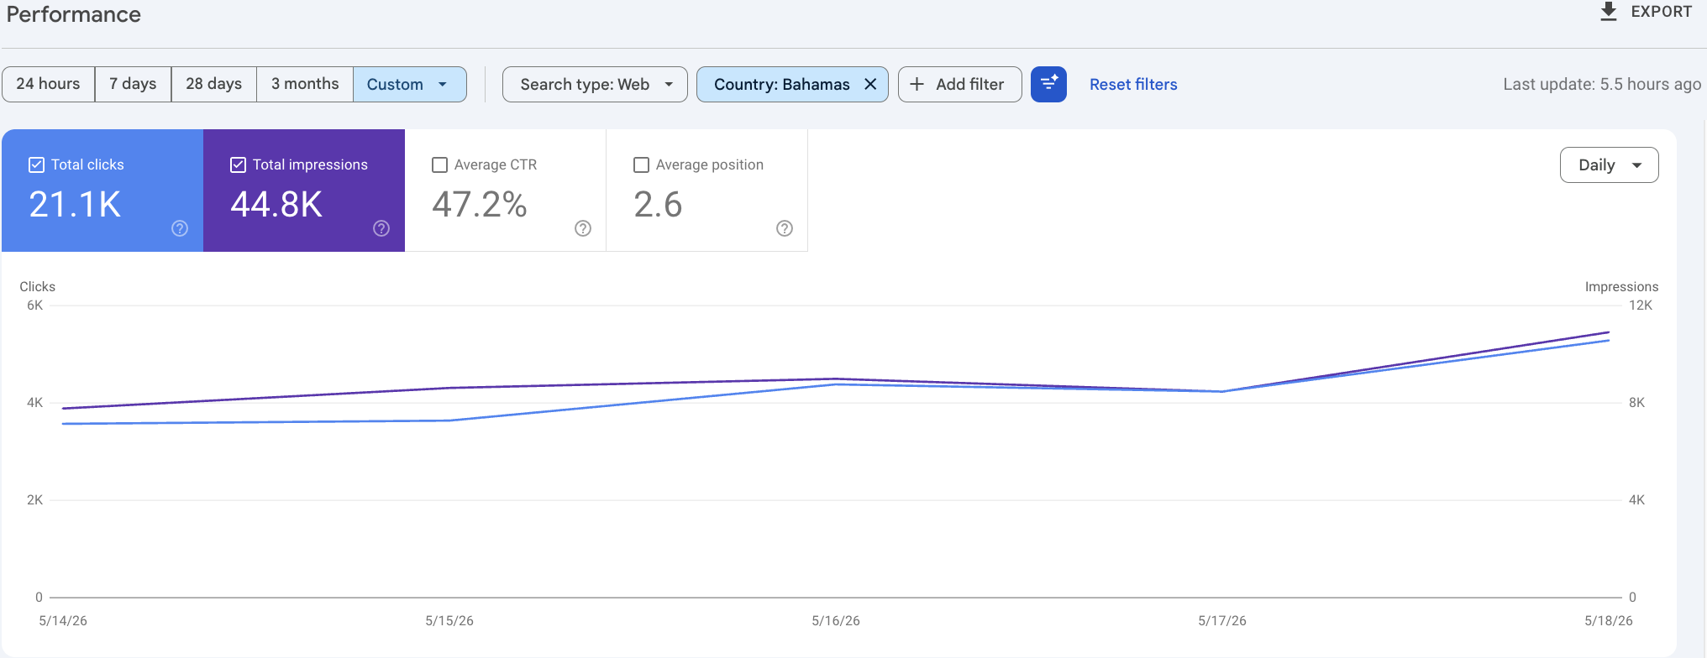
United States

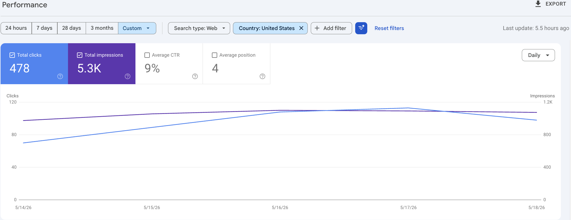

ANALYSIS
Google Search Console has only recently been set up, so this should be treated as an early baseline rather than a reliable long-term trend.

From 14 to 18 May 2026, the site recorded 58K impressions and 21.8K clicks, with a strong 37.7% CTR and an average position of 3.3. Both clicks and impressions increased across the short period, with a slight softening around 17 May before rising again on 18 May.

Performance is heavily concentrated in the Bahamas. The Bahamas accounted for 44.8K impressions and 21.1K clicks, with a 47.2% CTR and an average position of 2.6. This suggests strong visibility and engagement in the core market.

The United States generated 5.3K impressions and 478 clicks, with a 9% CTR and an average position of 4, showing some visibility but much lower engagement than the Bahamas.

Because the reporting window is very short, these figures should be monitored over the next few weeks before drawing firm conclusions about search performance trends.

Average Click Through Rate (CTR) vs Average Position
The graph below shows the average CTR on the left axis and the average position on the right axis. Note that the axes are different.

Average Click Through Rate refers to the percentage of impressions which result in a click. Average Position refers to the average position of your site in the search results.

Global
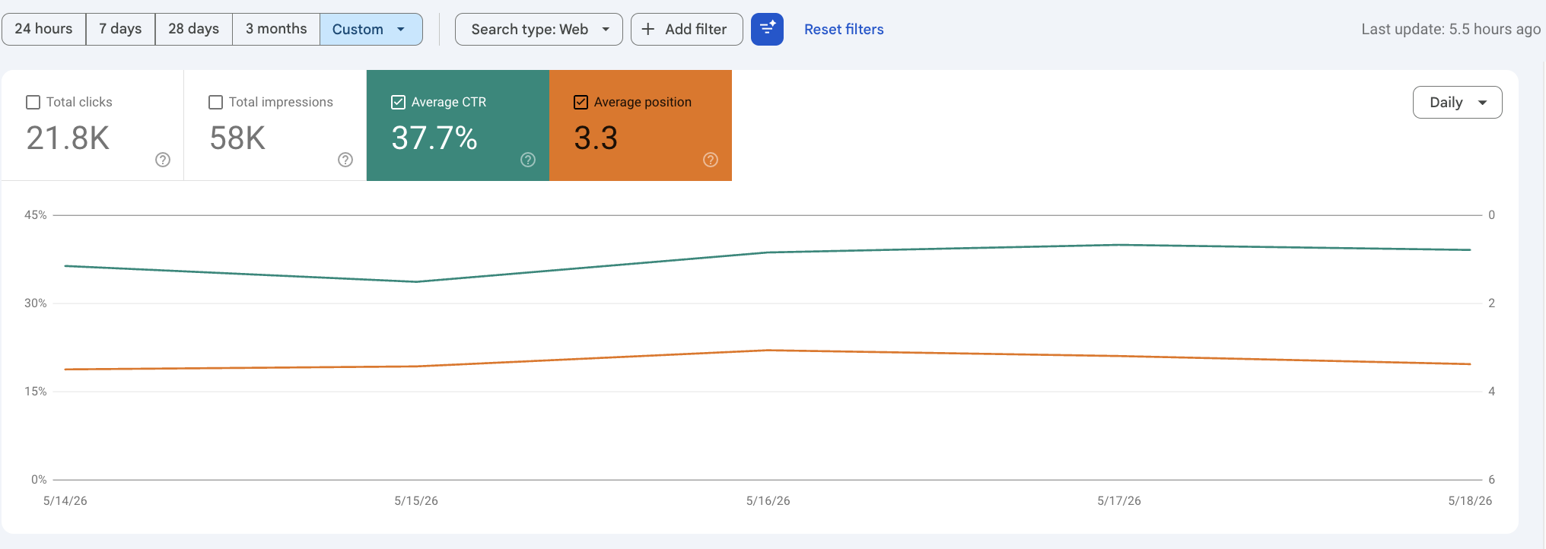

Bahamas
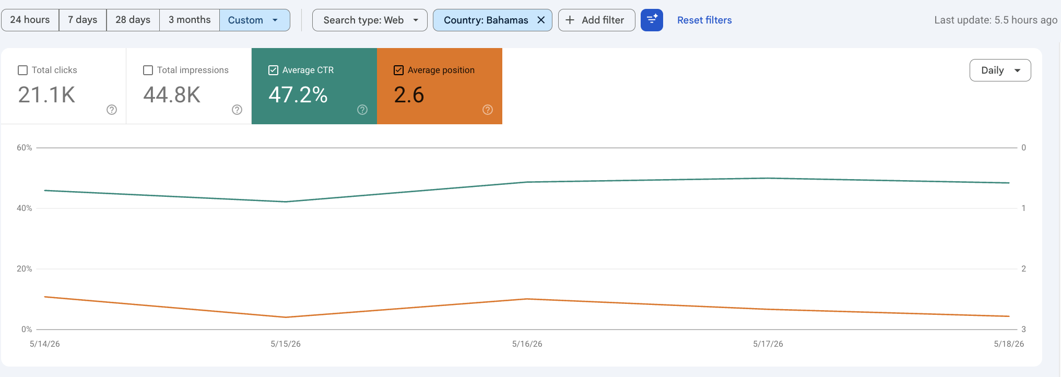
United States

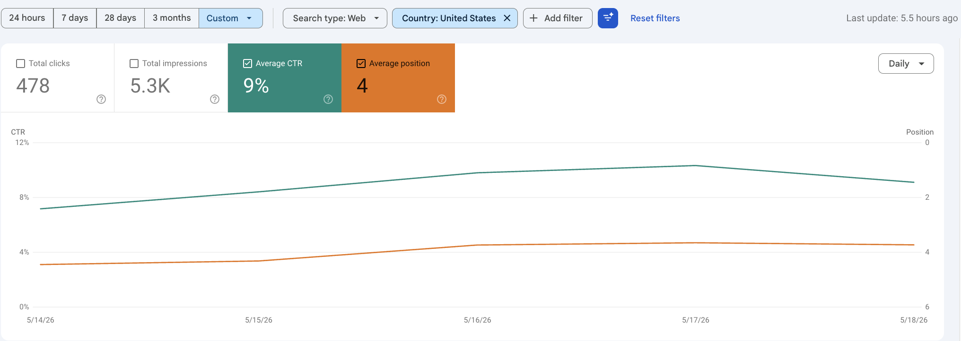

ANALYSIS
Google Search Console only has data from 14 to 18 May 2026, so the CTR and average position data should be read as an initial benchmark rather than a meaningful trend. Across all countries, the site recorded a strong 37.7% CTR and an average position of 3.3. CTR dipped slightly on 15 May, then improved through 16 and 17 May before easing slightly on 18 May. Average position stayed relatively stable around the top three to four results, which is a positive early signal.

The Bahamas is the strongest market in this short window, with a 47.2% CTR and an average position of 2.6. This suggests that the site is ranking very prominently for the queries currently driving visibility there, and that users are engaging strongly when the site appears in search results.

The United States shows a different pattern: 9% CTR and an average position of 4. This is still a good average ranking position, but the lower CTR indicates that US searchers are less likely to click through. The next step is to keep monitoring this weekly as more GSC data becomes available, especially to see whether CTR remains high in the Bahamas and whether US search snippets can be improved.

Recommendations
RECOMMENDATIONS
- Monitor CTR and average position weekly as more GSC data becomes available, with particular attention on maintaining the strong Bahamas CTR and improving US search snippet appeal where rankings are visible but click-through is lower.


Technical SEO
lTECHNICALl lSEOl
There are numerous aspects of a website which directly affect user experience as well as the ability of search engines to crawl the website. The aspects we consider here are typically sitewide rather than page specific, and fixing the problems should result in improvements across the site.

We crawled your website with a premium SEO tool called Ahrefs. The summary report created by Ahrefs is good for an overview of SEO topics, but is too superficial for detailed analysis of a particular topic. Do not overly pay heed to the health score as it is not a perfect metric.

Low Value Pages, Indexing, & Robots.txt
Google interacts with your website by: firstly, crawling your website (inspecting URLs and ‘clicking’ links); secondly, indexing your URLs (storing and organising your URLs); and thirdly, ranking your URLs against other relevant URLs.

Google has a limited ‘crawl budget’ for each website (the number of pages it will crawl), so you don’t want Google crawling too many low value pages. You also don’t want indexing too many low value pages. Google has directly stated that a large site with too many low value pages can experience worsened SEO.

Low value pages include:
- WordPress category/tag pages
- Duplicate content
- Content/blog posts which are low-quality or outdated
- Ecommerce product pages with zero sales
- Archive pages
- Print pages, sorted/filtered pages, other parameter pages
- Old services pages
- Orphen pages (pages with on incoming links)

A robots.txt is a text file that resides in the root directory of your website and gives search engine crawlers instructions as to which pages they can crawl and index. When visiting a website, the first thing they do is to look for the robots.txt file and check its contents.

While you can request for Google not to index a page in your robots file, you can also request Google not to index a page using a ‘noindex’ meta tag on the page itself. This can be useful as you don’t want to bloat your robots.txt file with too many rules.

Here we look at whether your robots.txt file is set up and what it is (and is not) blocking. We also use Ahrefs data to look at indexing.

DATA COLLECTION

 | Orphan pages - Paradise Games

FINDINGS

- There are no orphan pages
- There are a limited number of indexable pages
- In addition, there are multiple versions of the website are visible to search engines (URL prefixes and a subdomain)
  - https://pggames.com/
  - https://www.pggames.com/
  - https://www.pggames.com/home/contactsupport
  - https://pggames.com/home/contactsupport
  - https://classic.pggames.com/Mobile/Results
  - https://classic.pggames.com/Mobile/SignUp
  - https://classic.pggames.com/Mobile/RecoverPin
  - https://classic.pggames.com/Mobile/Terms
  - https://pggames.com/footer
  - https://www.pggames.com/footer
  - https://classic.pggames.com/Mobile/
- n/a

RECOMMENDATIONS
- Ensure only one version of the site in terms of URL prefix is visible to search engines.
- Expand on the site’s coverage in order to create internal links between pages.
  - See landing page ideas for more information.

XML Sitemap
An XML sitemap is a list of all the pages of your site, displayed in a way that Google can understand. It is common to put a link to your sitemap(s) in your robots.txt file as well as log it with Google Search Console to ensure that Google can find the sitemap.

Here we look at your XML sitemap. We consider the sitemap with respect to your robots.txt file (you wouldn’t want a URL in your sitemap which was being blocked or noindexed).

DATA COLLECTION

 | Indexed pages missing from sitemap - Paradise Games

FINDINGS

- n/a
- n/a
- There is no sitemap set up.
- Sitemap has not been submitted to Google Search Console and Bing Webmaster tools.
- Indexable pages are missing from the sitemap.

RECOMMENDATIONS
- Create a sitemap
  - Submit it via Google Search Console and Bing Webmaster tools
  - Ensure the sitemap is clean (only one version of the site in terms of URL prefix should be present).

- A sitemap.xml has been generated using the current Ahrefs crawl export, limited to URLs marked as indexable, that return HTTP 200 and are served as HTML pages. This provides a baseline sitemap for the URLs Ahrefs was able to discover and classify as indexable.
See:Provisional Sitemap Paradise Games
  - However, additional public-facing URLs were identified through live site navigation and JavaScript-triggered routes that were not picked up as page URLs in the Ahrefs crawl. These pages return HTTP 200 and should be reviewed before deciding whether they should be added to the XML sitemap
  - URLs to review:
https://www.pggames.com/Casino
https://www.pggames.com/Casino/Index
https://www.pggames.com/Lottery
https://www.pggames.com/Lottery/Index
https://www.pggames.com/Sports
https://www.pggames.com/Sports/Index
https://www.pggames.com/Home/Results
https://www.pggames.com/Lottery/paradise34
https://www.pggames.com/home/promoandrewards
https://www.pggames.com/footer?footerHeader=FAQ&footer=WebCafeFQsV12
https://www.pggames.com/footer?footerHeader=AboutUs&footer=WebCaeAboutUsV12
https://www.pggames.com/footer?footerHeader=HowToPlay&footer=WeCafeHowToPlayV1
https://www.pggames.com/footer?footerHeader=TermsAndConditions&footer=WebCafeTAndCV12
https://www.pggames.com/footer?footerHeader=Privacy&footer=WebCafePrivacyV12
https://www.pggames.com/footer?footerHeader=ResponsibleGambling&footer=WCResponsibleGamingV12
https://www.pggames.com/footer?footerHeader=Cookies&footer=CookiesTextV12
https://www.pggames.com/footer?footerHeader=Careers&footer=Careers

Duplicate Content & Canonicalisation
Duplicate content occurs when the identical (or nearly identical) content which appears on multiple URLs. Duplicate content can cause a drop in rankings. There are various ways in which duplicate content can arise on your site, as well as various solutions to duplicate content.
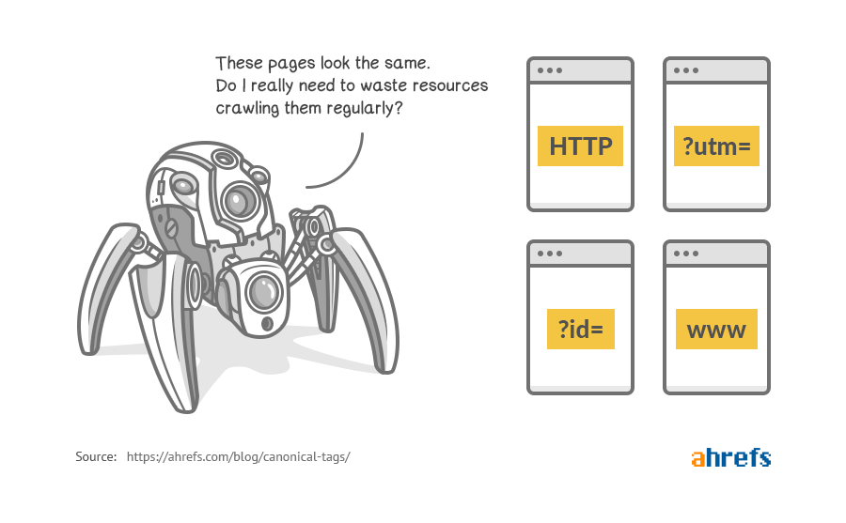

A canonical tag lets Google understand that the URL is the ‘master version’ of the copy of a page. This comes into effect often on ecommerce sites where a particular product may have multiple versions (due to e.g. parameters in the URL). This prevents the risk of being targeted for duplicate content.

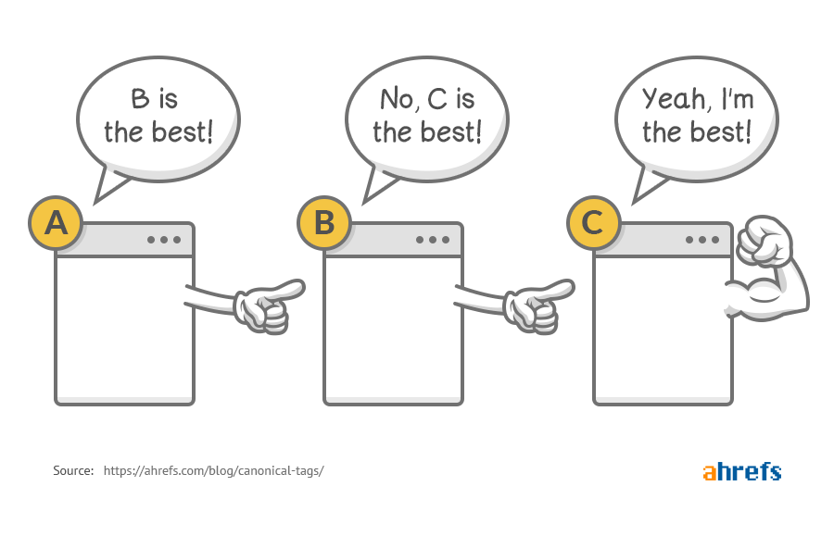
In this section we will look at duplicate content on your site and your use of canonical links by analysing Ahrefs data.

DATA COLLECTION

 | Duplicate content - Paradise Games

FINDINGS

- n/a
- Paradise Games still has duplicate URL variants because both https://pggames.com/ and https://www.pggames.com/ resolve as indexable 200 pages. The same pattern appears on contact-support and footer URLs.
- The classic mobile subdomain should also be reviewed for canonical handling because several classic mobile pages are indexable 200 pages and may overlap with the main experience.
- N/A

RECOMMENDATIONS
- Select a preferred HTTPS hostname, either root or www, and redirect the alternate HTTPS hostname to it.
- Ensure all http URLs 301 redirect to the https equivalent.
- Add or confirm self-referencing canonicals on the preferred pages, clarify canonical rules for classic.pggames.com mobile pages, and re-export the duplicate-content report for Paradise Games so this section can be fully verified against the correct source file.

Structured Data & Rich Results
Google Search works hard to understand the content of a page. You can help by providing explicit clues about the meaning of a page to Google by including structured data.

Structured data is a standardized format for providing information about a page and classifying the page content; for example, on a recipe page, what are the ingredients, the cooking time and temperature, the calories, and so on.

DATA COLLECTION

 | Home page structured data |  | Home page rich results
 | About page structured data (no page) |  | About page rich results (no page)
 | Contact page structured data |  | Contact page rich results

FINDINGS

- n/a
- N/A
- Structured data and rich results should be implemented consistently across the key page templates.

RECOMMENDATION
- Add only the schema types that match the visible content on each page, such as Organization, LocalBusiness, WebSite, BreadcrumbList, Game, and FAQPage.
- Add WebSite search action schema if the on-site search function is available and indexable.
- Use FAQ schema only on pages that visibly include matching FAQ content.
- Make sure all schema URLs, business details, logos, social profiles, and contact details match the preferred HTTPS version of the site.
- Avoid duplicate or conflicting schema blocks across the root domain, www variant, and classic mobile subdomain.
- Use Google's Rich Results Test and Schema Markup Validator after implementation to confirm there are no warnings or invalid fields.

Mobile Friendliness
Google has declared that mobile responsiveness is now a factor for ranking in Google search result pages, as a large majority of users access the internet through their mobile devices.

In fact, Google considers the mobile version the PRIMARY version of your website (Mobile first indexing). It is therefore imperative to have a mobile optimized site for healthy search engine rankings.



Source: Google

We use the Google mobile responsive test to see how Google views your website on mobile devices: https://search.google.com/test/mobile-friendly

DATA COLLECTION

 | Mobile Friendliness test

FINDINGS

- The site is responsive and the main page content is readable on mobile without obvious horizontal scrolling.
- Important account, registration, support, and game journey pages are accessible from mobile-oriented URLs.
- The mobile experience is held back by performance issues, especially slow largest content loading and a high server response time.
- Mobile PageSpeed evidence shows poor LCP and TTFB, which means users may wait too long before the main content becomes usable.
- The page is heavy for mobile users, with Pingdom showing a 13.6 MB page size, 100 requests, and 10.2 MB of image weight.
- JavaScript is also a meaningful contributor, with 22 script requests and 2.7 MB of script weight.
- The mobile journey still relies on classic mobile URLs and some redirected paths, which adds friction to navigation and account journeys.
- Sign-up, results, recover PIN, terms, and contact-support journeys should be tested on real mobile devices because these are important conversion and support paths.
- Links from the classic mobile interface should point directly to final URLs rather than redirecting through SwitchUI or non-trailing-slash variants.
- Remove unnecessary intermediate steps in mobile account and game-selection flows.
- Make form requirements and next steps clear before users submit details.

RECOMMENDATIONS
- Prioritise mobile LCP and TTFB improvements before smaller visual changes.
- Compress and resize above-the-fold images, then serve them in WebP or AVIF where possible.
- Preload the main above-the-fold image and any critical font files used in the first viewport.
- Defer or delay non-critical JavaScript, especially third-party scripts and chat/support assets that are not required for the first render.
- Lazy load below-the-fold images, carousels, and promotional media.
- Update mobile navigation links so they point directly to final URLs rather than redirected classic mobile paths.
- Test the full mobile sign-up, results, recover PIN, terms, and contact-support journeys on real devices.
- Make key mobile actions such as sign up, results, recover PIN, contact support, and responsible gaming easy to reach.
- Review form labels, validation messages, and next-step prompts on mobile so users understand what to do before submitting details.
- Keep game, lottery, casino, and sportsbook paths fast and easy to use on mobile.

Speed Test & Performance
Google has stated that page loading speed is an SEO ranking signal. Furthermore, it affects user experience - slow sites are horrible to use. You can boost your site speed by using a CDN, compressing images, and switching to faster hosting.

 | CDN  CDN is short for content delivery network, which is a system of distributed servers (network) that deliver pages and other web content to a user, based on the geographic locations of the user, the origin of the webpage and the content delivery server. This service is effective in speeding the delivery of content of websites with high traffic and websites that have global reach.

Here’s an image from CloudFlare which depicts this perfectly:
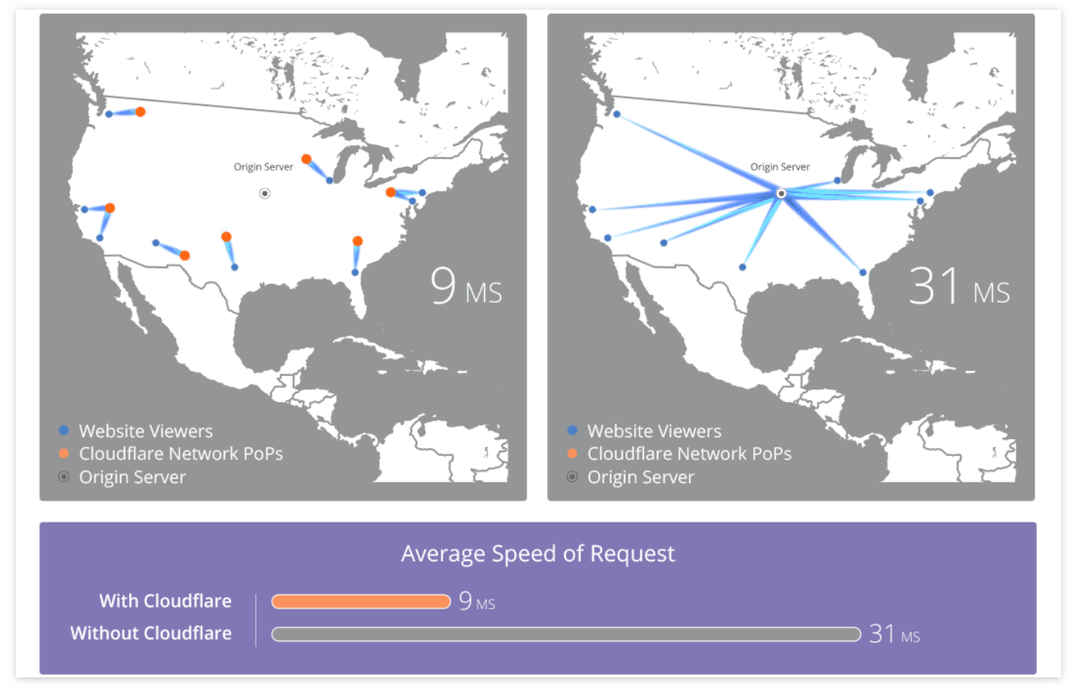
By using a CDN, like CloudFlare, when someone visits your website, the images will be loaded from the server closest to them.

We want to make sure your site doesn’t take more than 4 seconds to load: MunchWeb found that 75% of users wouldn’t re-visit a site that took longer than 4 seconds to load.

FINDINGS

Here are the current Pingdom test results for the home page:

Test Results | GTMetrix | Pingdom | WebPageTest
Page Size | Test failed | 13.6 MB | Test failed
Load Time | Failed | 963 ms | Failed
Requests | Failed | 100 | Failed
*Pingdom test run from the United States server.

- Pingdom returned a D66 performance grade.
- The homepage loaded in 963 ms in this test, but the page is still heavy at 13.6 MB.
- The page made 100 requests, including 45 image requests, 22 script requests, 16 CSS requests, 5 XHR requests, and 5 font requests.
- Images account for 10.2 MB, or 74.69% of total page weight.
- Scripts account for 2.7 MB, or 19.48% of total page weight.
- pggames.com serves most of the page weight and requests: 10.3 MB and 73 requests.
- Third-party assets also add weight, especially kendo.cdn.telerik.com at 1.7 MB, chat-assets.frontapp.com at 695.9 KB, and cdnjs.cloudflare.com at 556 KB.
- There are 2 302 responses, and Pingdom flagged fewer HTTP requests, gzip compression, cookie-free static assets, expires headers, DNS lookups, and URL redirects as priority performance opportunities.

RECOMMENDATIONS
- Reduce image weight first, as images make up nearly three quarters of the page size.
- Resize large images to their rendered dimensions before upload and convert suitable assets to WebP or AVIF.
- Audit the 22 script requests and remove, defer, or delay anything that is not needed for the first render.
- Review Kendo, Front chat, cdnjs, jsDelivr, and other third-party assets to confirm each one is still needed.
- Enable gzip/Brotli compression, add long-lived cache headers, lazy load below-the-fold assets, and update any internal links or asset references that cause 302 responses.

Security Check & Malware Scan
Often a large drop in rankings occurs when a site is hacked with Malware. The hackers use your site to generate hundreds of spammy links and pages advertising unsavoury products such as payday loans or viagra pills.



FINDINGS

We ran your site through Google Security and Sucuri Scans. These are services which check for malware and hacks.

- We found no evidence of any malicious malware or code.
- The links below lead to the reports:
  - https://sitecheck.sucuri.net/results/https/pggames.com
  - https://transparencyreport.google.com/safe-browsing/search?url=https:%2F%2Fpggames.com%2F&hl=en_GB
- N/A
- N/A

RECOMMENDATIONS
- N/A

Website Structure & Depth
Ideally you want a flat website structure. This means that ideally it should not take more than 3 clicks to go from your homepage to any page on your site. After all, if your ‘money page’ has to be reached by clicking (say) 8 times, then not that many people will end up getting to it. In order to analyse this for your site, we visually represent your website structure using a tool called Visual Site Mapper. We use Ahrefs data to further analyse page depth.

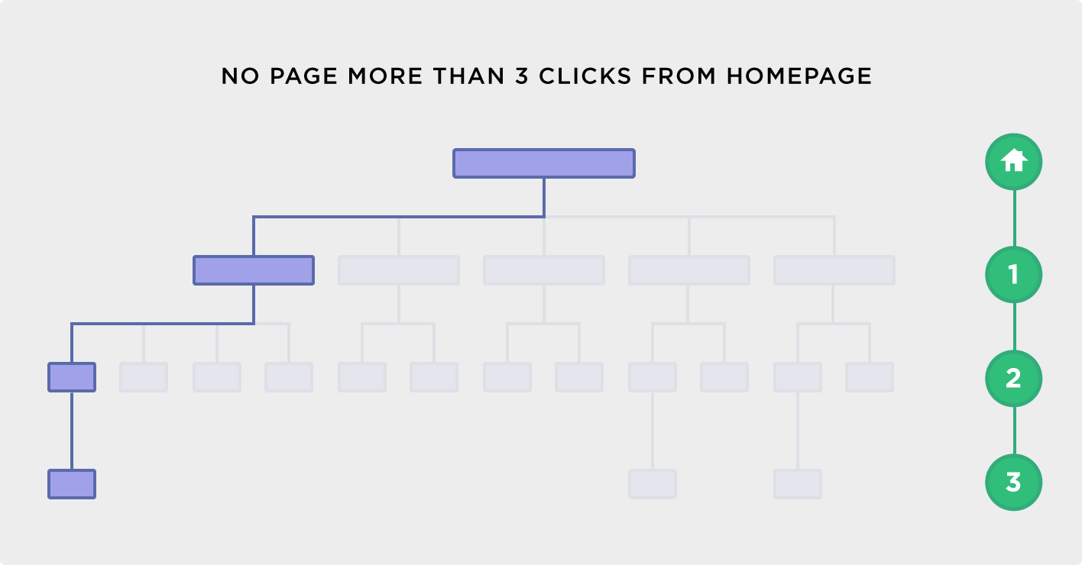

FINDINGS

- The site has a relatively shallow architecture, with the deepest pages found within 3 clicks.
- Most important pages appear reachable within 2 clicks from the homepage or main navigation.
- Classic mobile URLs, account journey URLs, and support URLs should be reviewed so their internal links point directly to final destinations.
- N/A
- N/A

RECOMMENDATIONS
- None

________________

Content Management System
This section deals with sitewide problems which can occur due to problems specific to your Content Management System (CMS). These problems revolve around using outdated versions of the CMS and plugins, as well as lacking important plugins (ie. Yoast for WordPress).
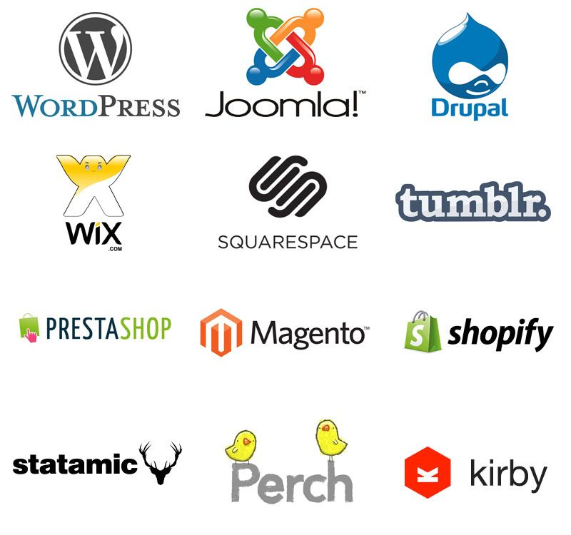



lCONTENTl lMANAGEMENTl lSYSTEMl

General CMS
It's important to keep your CMS Core up-to-date. CMS updates include important performance and security fixes, which ensures that your site loads quickly and is secure from vulnerabilities.

FINDINGS

- n/a
- n/a
- n/a

RECOMMENDATIONS
- n/a

Yoast
Yoast SEO is a powerful Wordpress plugin that helps in optimizing your site. While it might not be essential in the strictest sense of the word, it is highly recommended.

FINDINGS

- N/A
- N/A
- Not up-to-date

RECOMMENDATIONS
- n/a

Plugins
Over time most websites accumulate a number of plugins to enhance some aspect of the website or make some task easier. Some plugins will have security issues which crop up and are fixed by the plugin creator, and so it is important to monitor your plugins and keep them up-to-date.

FINDINGS

- N/A
- n/a
- N/A

RECOMMENDATIONS
- n/a


Summary and Conclusion
lSUMMARY &l lCONCLUSIONl
Paradise Games has a solid technical base in several important areas. The domain is branded, uses an appropriate .com TLD, has an active SSL certificate, and does not show evidence of malware or security warnings. The site structure is also relatively shallow, with key pages generally reachable within a small number of clicks.

The strongest current organic signal is in Google Search Console. Because GSC has only recently been set up, the available data covers 14 to 18 May 2026 and should be treated as an early benchmark rather than a long-term trend. Within that short window, the site recorded 58K impressions and 21.8K clicks, with a 37.7% CTR and average position of 3.3. The Bahamas is the clear core market, accounting for 44.8K impressions and 21.1K clicks, with a 47.2% CTR and average position of 2.6. The United States has some visibility, but engagement is much lower, with 5.3K impressions, 478 clicks, a 9% CTR, and average position of 4.

The main technical issues relate to URL consistency, crawl efficiency, mobile performance, and reporting completeness. The root and www HTTPS versions both resolve, which leaves the preferred hostname unclear. Internal links also point through avoidable redirected classic mobile paths, and the audit found two 404 issues: a broken PDF path and a missing promotional image asset.

Performance and mobile experience should be treated as priority areas. Pingdom shows a heavy 13.6 MB homepage with 100 requests, including 10.2 MB of images and 2.7 MB of scripts. PageSpeed and Search Console evidence also point to poor LCP, high server response time, and mobile INP issues.

Overall, the site is not in a poor technical state, but it needs cleanup and monitoring. The priority should be to consolidate URL signals, reduce avoidable redirects and broken assets, improve mobile speed, keep structured data consistent, and continue monitoring Search Console as more data becomes available after creating dedicated landing pages and content to drive organic traffic.

Areas for Improvement
Here we will discuss the sections of this audit: focusing on whether your website is healthy or whether it has problems, and what actions we suggest you take to address the problems.

Domain
DOMAIN | 3 suggested actions
The domain setup is mostly healthy, but the preferred HTTPS hostname should be clarified.

- Consider making paradisegames.com the domain, with pggames redirecting, for exact match targeting and to avoid confusion.
- Choose one preferred HTTPS hostname, either root or www.
- Redirect the alternate HTTPS hostname to the preferred version.
- Keep HTTP-to-HTTPS redirects in place.
- Align internal links, canonicals, structured data URLs, and sitemap references with the preferred HTTPS version.
- Consider migration to paradisegames.com

301 Redirects & 404 Errors
301 REDIRECTS & 404 ERRORS | 6 suggested actions
Redirect and 404 issues are limited, but there are avoidable internal redirects and broken assets that should be cleaned up.

- Update internal links so they point directly to final URLs rather than 302 redirect URLs.
- Prioritise classic mobile navigation, sign-up, results, recover PIN, terms, and support links.
- Fix the broken Gamingbill2014.pdf link from the mobile Terms page.
- Restore or replace the missing promo-image.jpg asset.
- Improve the 404 page with a clear Back to Home action and useful recovery links.

Google
GOOGLE | 3 suggested actions
Google Search Console is now active, but the dataset is still too short to use for long-term trend analysis.

- Monitor GSC weekly as more data becomes available.
- Track Bahamas performance separately, as this is currently the strongest market.
- Review US queries and snippets where rankings are visible but CTR is lower.
- Add or verify a domain property and the remaining URL variants in Search Console.
- Continue monitoring Core Web Vitals, especially LCP and INP on mobile.

Technical SEO
TECHNICAL SEO | 3 suggested actions
The biggest technical SEO priorities are sitemap consistency, low-value indexable pages, canonical clarity, structured data consistency, and mobile performance.

- Create an XML sitemap index. Ensure it references only HTTPS sitemap files.
- Set low-value tag, product-tag, and relevant category archive pages to noindex where appropriate.
- Confirm canonical rules across the preferred domain, www variant, and classic mobile URLs.
- Keep valid structured data in place and add only schema types that match visible page content.
- Reduce image weight, defer non-critical JavaScript, add long-lived cache headers, and improve mobile LCP and TTFB.
- Keep priority pages within three clicks and add contextual links to valuable orphan pages.

CMS (WordPress)

CMS (WORDPRESS) | 8 suggested actions
N/A

- n/a

CMS (WORDPRESS) | 6 suggested actions
N/A

- n/a


Appendices
lAPPENDICESl

Appendix: References and resources
This audit is made possible due to the research and efforts of Google and the SEO community.
Here are a number of incredible tools, articles and resources that we used to develop and perform this audit.

https://www.digicert.com/ssl/
https://analytics.google.com
https://search.google.com
https://tools.pingdom.com/
https://gtmetrix.com/
https://www.webpagetest.org/
https://transparencyreport.google.com
https://yoast.com/
https://yoast.com/meta-descriptions/
https://sitecheck.sucuri.net
https://ahrefs.com/
http://www.copyscape.com/
https://www.gotchseo.com/seo-audit/
https://neilpatel.com/blog/seo-website-audit/
https://backlinko.com/google-ranking-factors
https://backlinko.com/seo-site-audit
https://backlinko.com/on-page-seo
https://backlinko.com/link-building-strategies
https://www.searchenginejournal.com/the-ultimate-seo-audit-checklist/
https://www.thehoth.com/blog/google-medic-update/
https://barracuda.digital/panguin-seo-tool/
https://www.reliablesoft.net/seo-checklist/
https://www.google.com/business

